Pagemark Install Manual
Version 0.13.2
Revision 1.0

Pagemark — Install Manual
Version 0.13.2 · Android

1. Requirements
- An Android phone or tablet running Android 7.0 (API 24) or newer.
- About 100 MB free storage (the app is ~30 MB; the library and cached covers are small).
- Optional, for specific features: a camera (barcode scanning), a screen lock or fingerprint (locked library), notifications (reminders), an internet connection (book lookup, updates). Tablets and foldables work too: the layout adapts to the screen.

2. Download
Releases are published at https://github.com/AxialForge/Pagemark/releases. Open the newest release and pick one APK:
File | Use it on
Pagemark-x.y.z-arm64.apk | Almost every phone from the last ~8 years (64-bit ARM). Choose this one unless it fails to install.
Pagemark-x.y.z-armv7.apk | Older 32-bit phones.

Not sure? Download the arm64 file. If Android says the app isn't compatible, use the armv7 one.

3. Install
- Open the downloaded .apk (from your browser's downloads or the Files app).
- Android will say your browser/Files app isn't allowed to install apps. On Android 8 and newer, tap Settings and turn on Allow from this source, then go back. On Android 7, turn on Unknown sources in Settings > Security instead.
- Tap Install, then Open.
Pagemark is signed with the author's key, so future updates install over it and keep your data.
> Play Protect may show "unrecognised app" because Pagemark isn't distributed through the Play Store. Choose Install anyway (or More details → Install anyway).

4. First run
Pagemark opens with three short welcome screens (Skip any time), then an empty Library. Tap Add book to start, or Try it with 5 sample books to look around (remove them again with Remove on the card in the Library). Allow the camera only if you want to scan barcodes. Android 13 and newer asks once for notifications the first time you switch on a reminder (reading, backup or a lent book); everything else needs no permissions. The guide is always at Settings → How to use Pagemark, and Settings → Our promise to you says what Pagemark will never do.
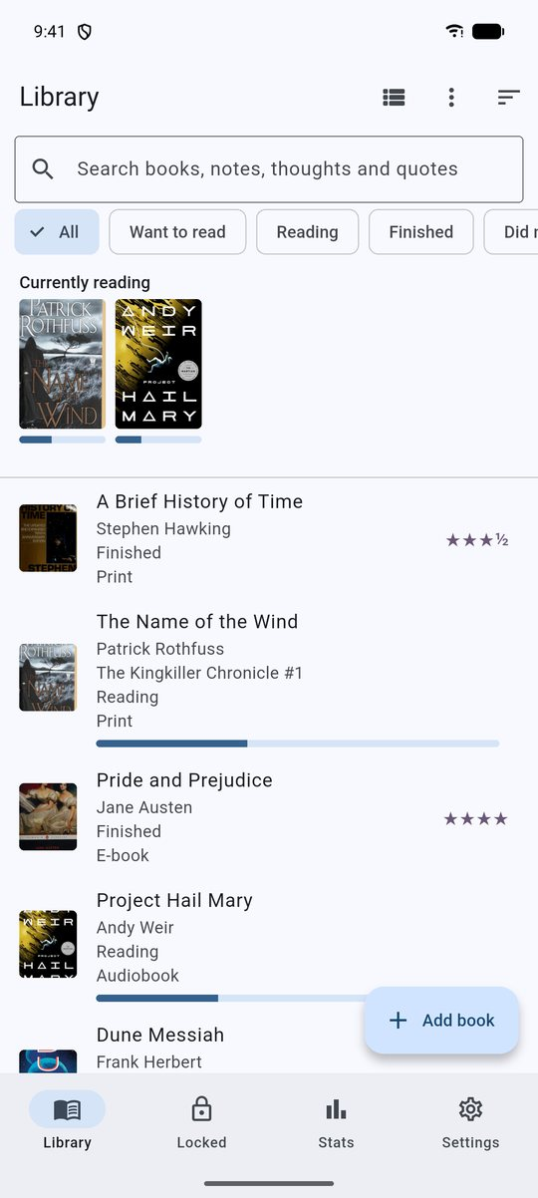
Pagemark with a few books added

Permissions Pagemark asks for
Permission | Why
Internet | Book lookup (Open Library and Google Books), cover pictures, update check (GitHub version only)
Camera | Scanning ISBN barcodes (asked only when you open the scanner)
Biometric | Fingerprint/device unlock for the locked library
Notifications | Reading, backup and lent-book reminders (asked when you switch one on)
Run at start-up | Sets reminders again after the phone restarts
Vibrate | A small buzz when a barcode is scanned
Install packages | Lets Android offer to install a downloaded update (GitHub version only)

Pagemark does not ask for storage, photo, contacts, location, microphone or Bluetooth permissions. Some phones list Nearby devices under a general "network" label for any app that uses the internet; Pagemark does not request it. Backups are saved with Android's own file and folder pickers, so no storage permission is needed.

5. Updating
In the app: Settings → Updates → *Download & install*. Android asks once to allow installs from Pagemark. You can also let it check once a day automatically.
By hand: download the newer APK from Releases and open it — it installs over the old version.
Your library, shelves, settings and PIN are all kept. Make a backup first if the library matters to you (Settings → Backup and restore → Save a copy as a file). After an update, open Pagemark once so your reminders are set again.

6. Uninstalling — read this first
Uninstalling Pagemark deletes your library from the phone (Android's own backup is disabled on purpose). Before you uninstall or switch phones:
- Settings → Backup and restore → Save a copy as a file (set a password) and keep the file safely, or make sure the backups Pagemark saves to your chosen folder (for example one inside Google Drive) are recent.
- On the new phone, install Pagemark and use Restore — a backup from an older Pagemark version restores fine; one from a newer version does not.
The PIN is not stored in backups. After restoring, set a new PIN for the locked library.

7. Keeping your library safe
Settings → Backup and restore → Save a copy as a file (protect it with a password) and keep the file somewhere other than this phone, or choose a folder (on the phone, a USB drive, or inside Google Drive, OneDrive or Dropbox) and Pagemark saves a fresh backup there by itself, keeping the newest five. Pagemark can also remind you every week, two weeks or month.
For the official release APK, the signing-key SHA-1 is:
39:04:59:AD:24:0F:35:99:4B:CD:A5:86:81:AF:9C:21:8C:FD:27:F7

8. Building from source (developers)
``bas
git clone https://github.com/AxialForge/Pagemark.git
cd Pagemark
flutter pub get
dart run build_runner build --delete-conflicting-outputs # regenerates lib/db.g.dart
flutter analyze && flutter test
flutter build apk --release --split-per-abi
`
Requirements: Flutter 3.47+ (stable), Android SDK, JDK 17+.
Windows with a very new JDK (25): Gradle can fail with *"Unable to establish loopback connection"*. Create a short folder such as C:\tmpj and run the build with
JAVA_TOOL_OPTIONS=-Djdk.net.unixdomain.tmpdir=C:/tmpj.
Signing: create a keystore, put its path and passwords in android/key.properties (this file is git-ignored; never commit it). Without it, release builds fall back to the debug key, which can't upgrade a release install. Release APKs are signed with APK Signature Scheme v2 and v3. tool/build.ps1 builds both APKs and the Google Play bundle for the current version.

9. Troubleshooting
Symptom | Fix
"App not installed" | A different signing key is already installed (e.g. a debug build). Back up, uninstall, install the release APK.
"There was a problem parsing the package" | The download was cut off or you picked the wrong architecture; re-download or use the other APK.
Install blocked | Allow "install unknown apps" for the app you opened the APK from.
Update says "No public releases found" | Check connection; the project's releases must be public.
Fingerprint option missing | Set a screen lock/fingerprint in Android settings first.
Scanner is black | Allow the camera permission in Android → Apps → Pagemark.
Reminders never appear | Settings → Notifications in Pagemark should say notifications are on; also check Android → Apps → Pagemark → Notifications and Battery (choose *Unrestricted* if offered). Versions before 0.13.2 never showed scheduled reminders; update, then open Pagemark once.

